**NAME: JEEVITHA.S-192324020**

**DATA BASE MANAGEMENT SYSTEM FOR DATA APPLICATIONS(CSA0555)**

**ASSIGNMENT 4: JOIN OPERATIONS**

**JOINING 2 TABLES USING JOIN CLAUSE**

**TYPES OF JOIN COMMANDS**

1.Outer join

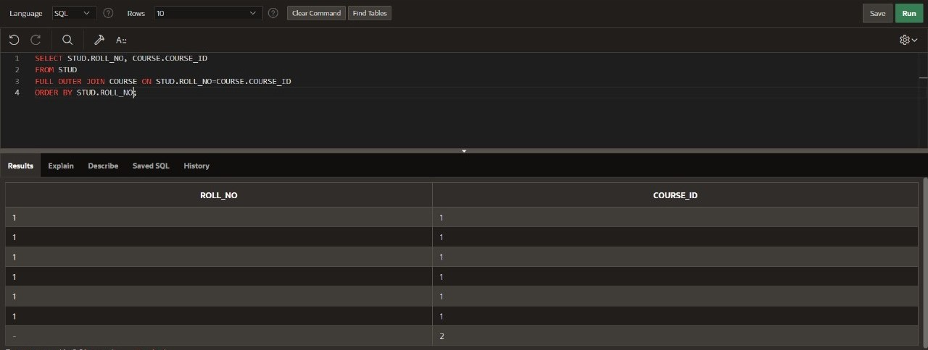

2.Left join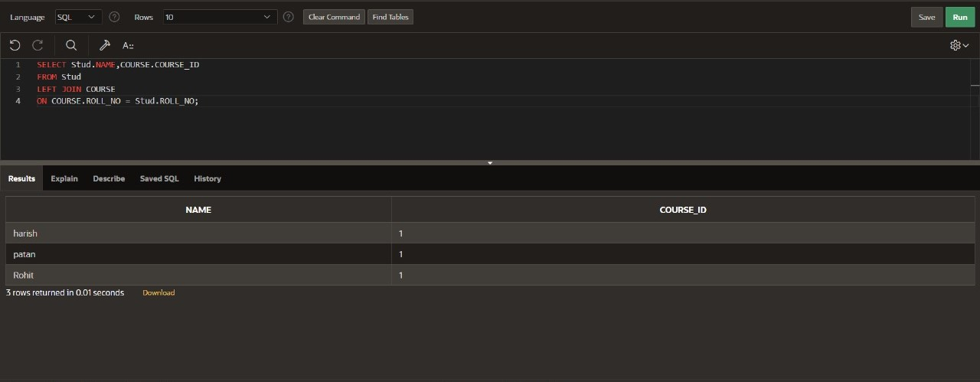

3.Self join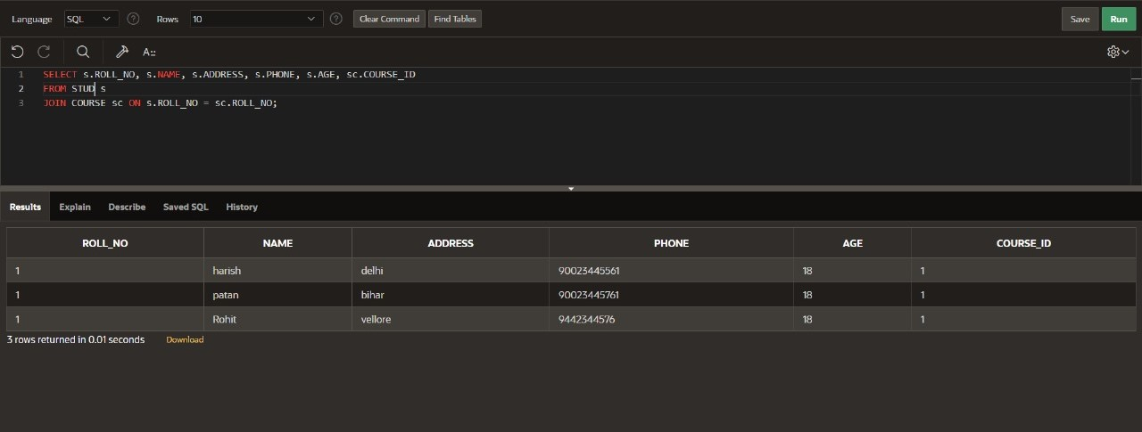

4.Inner join